**FINDINGS:**

**Analytical methods**:

Comparison of historical vs present distributions of species are prone to error because of differences in sampling design and methods and errors in location and/or species identity. In the case of the Grinnell Resurvey Project, the latter are minimized as we have access to the extensive field notes and historical maps (location and sampling effort) and the specimens themselves (species identity). Relative to other studies of range change over time, our prime innovation was to employ occupancy modeling in order to control statistically for differences in sampling effort and detectability of species within and across time periods (Tingley & Beissinger 2009). This is especially important to estimate the probability of non-detection when a species is in fact present (i.e. false absences, pfa). In addition, we modeled species probability of occupancy as a function of elevation and time period, with appropriate tranforms and covariates. Thus in all our analyses of changes in species elevational range and for spatial modeling in a presence/absence framework, we restrict inference of “absence” to cases where pfa is low. Extensive simulations of this occupancy-based strategy (Tingley et al. in press) demonstrate that it is appropriately conservative (type I error < 2%) while maintaining reasonable overall power (>80%).

**Changes in elevational ranges.**

For small mammals, we obtained statistically robust data across the three major transects for 33 species. Across the central (Yosemite) transect, approximately half the species shifted one or both elevation limits upwards, with an average shift of ~500m over the 90 year period between surveys (Moritz et al. 2008). This translated into mostly upwards expansions of a few (3) formerly low elevation species and range contractions of several (n = 8) high elevation species. The remaining species were mostly static, with just 2 species showing downwards expansions. This overall trend towards upwards shifts and contractions of high elevation species is associated with a regional increase of minimum temperatures of ~ 3C, consistent with the typical lapse rate of temperature with elevation. That said, not all shifts are necessarily associated with temperature increase; several low elevation taxa that expanded upwards were thought to be responding to fire-related vegetation dynamics. The most remarkable upwards colonization was a ~1km colonization by the eastern subspecies of the pinon mouse, *Peromyscus truei* from its typical pinon-juniper habitat on the east slope, across the Sierra crest to high elevation conifer forests (Yang et al. 2011). In a subsequent study, postdoc Maria Santos tested whether range dynamics of the Yosemite small mammals could be explained in general by vegetation change. By matching historical (1930’s Weislander) and current vegetation maps, and using the California Wildlife Habitat Relations models of habitat preferences, she demonstrated that expansions of low-mid elevation species were tracking vegetation change, whereas contracting species were not (Santos et al, in review). Thus, climate change remains the strongest hypothesis for the latter. Despite these individual range fluctuations, Yosemite National Park did not change in species richness, attesting to the robustness of biodiversity in protected areas that span elevational gradients (Moritz et al. 2008).

Expansion of the small mammal resurveys across the three major transects, spanning Lassen, Yosemite and Sequoia-Kings regions, revealed considerable heterogeneity of species’ responses across regions (Rowe et al., in prep.; see Figure). Consistent with initial results for Yosemite, the dominant signature is upwards shifts of range limits, especially of lower limits (“lagging edges”) of high elevation species, leading to range contraction of these taxa. By contrast, low elevation species were more heterogeneous in response. These trends occur across the three transects, for which the most consistent change in climate is increased minimum temperatures and mean annual precipitation. Historical climate variables for the upper and lower limits of species ranges suggest that changes in minimum temperatures are more reliable predictors of the direction of species’ elevational shifts than mean annual temperature, maximum temperature or mean annual precipitation. Of high elevation species, nocturnal, short-lived and obligate hibernators were most likely to show upwards range contractions. Species that contracted at their lower limits consistently across at least two transects included the alpine chipmunk (*T. alpinus*), Belding’s ground squirrel (*U. beldingii*), Pacific jumping mouse (*Z. princeps*), long-tailed vole (*M. longicaudus*), bushy-tailed woodrat (*N. cinerea*), and the water shrew (*S. palustris*). Other high elevation taxa showed more heterogeneous responses across transects, perhaps due to region-specific changes in seral dynamics, or interacting effects of local changes in temperature and precipitation. Further targeted surveys of the Belding’s ground squirrel across its Sierra Nevada range by postdoc Toni Lyn Morelli revealed that it has disappeared from 45% of its historical locations and colonized none. Again, these precipitous declines across the SW of the species range are primarily at lower warmer elevations, with the intriguing exception of anthropogenically “improved” habitats (irrigated areas, campgrounds etc.) (Morelli et al. in press).

One of the most remarkable features of these data is the heterogeneity of responses among closely related (ie congeneric) species. This applies to common taxa such as chipmunks, ground squirrels, shrews, voles and field mice. In general, we gained some insight into this from statistical analyses of potentially predictive life history and ecological traits, but much remains to be explained. In response, we have initiated a series of comparative studies of chipmunk species with differing response, especially *T. alpinus* (consistent and strong contractions) vs. *T. speciosus*, another high elevation species but which has remained relatively stable in elevational range. PhD student Emily Rubidge undertook comparative distribution modeling, including both climate variables and the presence of congeners, and found that climate alone best explained the contraction of *T. alpinus*, but that the presence of congeners (competition?) improved models for *T. speciosus* (Rubidge et al. 2010). Other studies in progress are comparing changes in diet and habitat use (e.g. using stable isotopes + field studies) and genetic/phenotypic comparisons (see below).

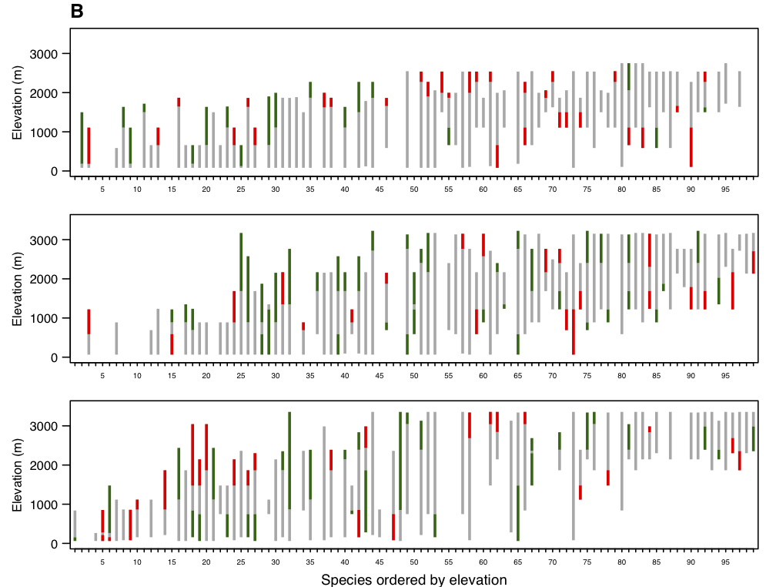For birds, resurveys across the three Sierra regions employed variable-distance point counts, whereas the Grinnell period data were primarily daily accounts of area surveys and/or collected specimens. Though the original surveys were less quantitative, they still permit occupancy-based analyses of species presence/absence, against which the resurveys can be compared. Overall, across the 77 resurvey transects we obtained robust data for 99 species of which 53 were common to all three regions. Compared to the small mammals, changes in upper or lower elevation range limits of birds were frequent (83%) but less elevationally coherent; shifts downwards were as common as shift upwards (Tingley et al. in press; see Figure). The expectation of coherent upwards shift reflect the naïve hypothesis that increasing temperate is the primary determinant of shift in elevational range. Yet, changes in both temperature and precipitation can affect range limits, either directly through physiological limits, or indirectly through habitat requirements or biotic interactions. The direction and magnitude of 20TH C changes in precipitation and temperature vary with elevation and latitude across the Sierra study region. When we considered local changes in both precipitation and temperature, the proportion of explained changes in range limits increased from 51% (temperature only) to 83%, reflecting the “push and pull” of climate change (Tingley et al. in press). As for small mammals, there is also considerable among-species variation in response to climate change. Avian Species were significantly more likely to shift elevational ranges than their ecological counterparts if they had small clutch sizes, defended all-purpose territories, and were year-round residents In principle, species are most likely to respond to changes in climate where the local effect is to move away from, rather than towards the optimum conditions (niche tracking). To test this hypothesis, we estimated the optimum conditions as the centroid of multivariate climate space occupied species-wide, and vectors of local climate change relative to this centroid (Tingley et al. 2009). Of the 53 species tested, 91% showed niche-tracking, consistent with our predictions. Intriguingly, lower elevation species responded more strongly on the precipitation axis, whereas higher elevation species responded primarily to temperature change. We hypothesise that this reflects changes in net primary productivity, which also is more constrained by precipitation at low elevation and temperature at high elevation, in which case range limits are primarily determined by indirect (ecological), than direct (physiological) effects. Further work could test this model through a combination a mechanistic models and incorporation of changes in NPP (or proxies thereof) in statistical models.

A further aim was to use the historical vs current distribution records to test performance of spatial distribution models when extrapolated over time, as it widely done for predicting impacts of future climate change. This depends on the veracity of the historical as well as present climate layers (ie the predictor variables), as we put considerable effort into evaluating different methods of extrapolation given sparse early 20th C weather records for the Sierra Nevada (Parra & Monahan 2008). Independently funded postdoc, Adam Smith, undertook this using the GRP small mammal data, developing SDMs using 6 widely employed methods and using species-wide occurrence (presence-only from museums) and evaluating the results against the GRP presence/absence data from the Sierra Nevada. An important innovation was to use the occupancy-derived estimates of detectability to reliably infer absences. In the events, these experiments, forecasting from historical observations/climate to the present, and vice versa, revealed relatively little difference among modeling methods, though with the widely used MaxENT model producing highly consistent results. However, there was considerable heterogeneity among species in model performance, and high accuracy (AUC) within a time period did not reliably predict accuracy across time periods (Smith et al., in prep.).

**Change in phenotype and genetic diversity**.

To gain more insight into proximate effects and causes of range changes, we have examined changes in phenotype and genetic diversity in contracting vs stable species of small mammals for which we have large series of specimens from both time periods. Focusing on ground squirrels (GS), undergraduate Lindsey Eastman compared skull length (correlated with overall body size) and tooth-row length in two contracting species (Belding’s and Golden-mantled GS) and one stable (Californian GS). Intriguingly, both contracting species showed significant increases in body size, even after controlling for difference in elevational range, whereas the Californian GS showed no change (Eastman et al. 2012). In contrast to skull length, often a plastic trait, there were no changes in tooth-row length. Preliminary comparative analyses of chipmunks indicate the same patter, with significant increases in skull length, especially the rostrum, in a contracting species (*T. alpinus*) and only minor shifts its relatively stable congener, *T. speciosus* (Assis & Patton, unpublished). Ongoing work, involving a graduate student (A.-P. Assis) and her faculty advisor (M. Garroig) from the University of Sao Paulo) is focused on applying evolutionary, quantitative genetic models to further understand these changes in phenotypes.

**Genetic diversity**.

Our initial study of changes in genetic diversity in relation to range changes have focused on comparison of the alpine (*T. alpinus*) and lodgepole (*T. speciosus*) chipmunks (Rubidge et al. 2012). In particular, we were interested to see whether the observed contraction and fragmentation of geographic range of the former within Yosemite National Park was accompanied by significant reduction and restructuring of genetic diversity. In accord with predictions, analyses of microsatellite diversity in population samples of historical skins vs modern samples of the two species demonstrated a significant reduction of overall diversity and increased among-population differentiation in *T. alpinus* and no change in *T. speciosus*. Thus, the observed range changes in the former reflect local population extinction and range fragmentation, rather than wholesale movement of populations. This study highlights the demographic challenges faced by contracting montane species, especially if historical trends are continued with future climate change.

While analyses using a small set of microsatellite loci are informative about recent demography, they do not inform adaptive responses or potential loss of evolutionary capacity. In response we have explored use of next-gen sequencing to undertake genomic analyses of museum skins vs modern samples. In our first foray, we demonstrated that small samples from museum skins can be used to generate extensive and accurate genomic data via Illumina sequencing (Rowe et al. 2011). To enable population genomics via sequence-reduction (exon capture), we then sequenced and assembled a transcriptome for *T. alpinus* (and *U. beldingi*) and, from this, developed an array-based exon capture system that enables highly efficient exome sequencing across all chipmunk species (Bi et al., in press). In further experiments (Bi et al., in prep.), we have applied this custom-capture array to population samples of early 20th C skins and shown equivalent or superior exome-scale sequencing efficiency to that from modern samples, and developed bioinformatics pipelines to detect and remove post-mortem DNA damage effects (ie. C-> T and G -> A, transitions). This sets the stage for population-genomic comparisons of contracting vs stable species (see Figure below), the ultimate goal of which is to identify genes or pathways under selection and thus direct phenotypic and ecological analyses of proximate causes of vulnerability to climate change. The new capacity for cost-effective “skinomics” also has the potential to dramatically increase the utility of well-curated collections of birds and mammals, such as that in the MVZ.

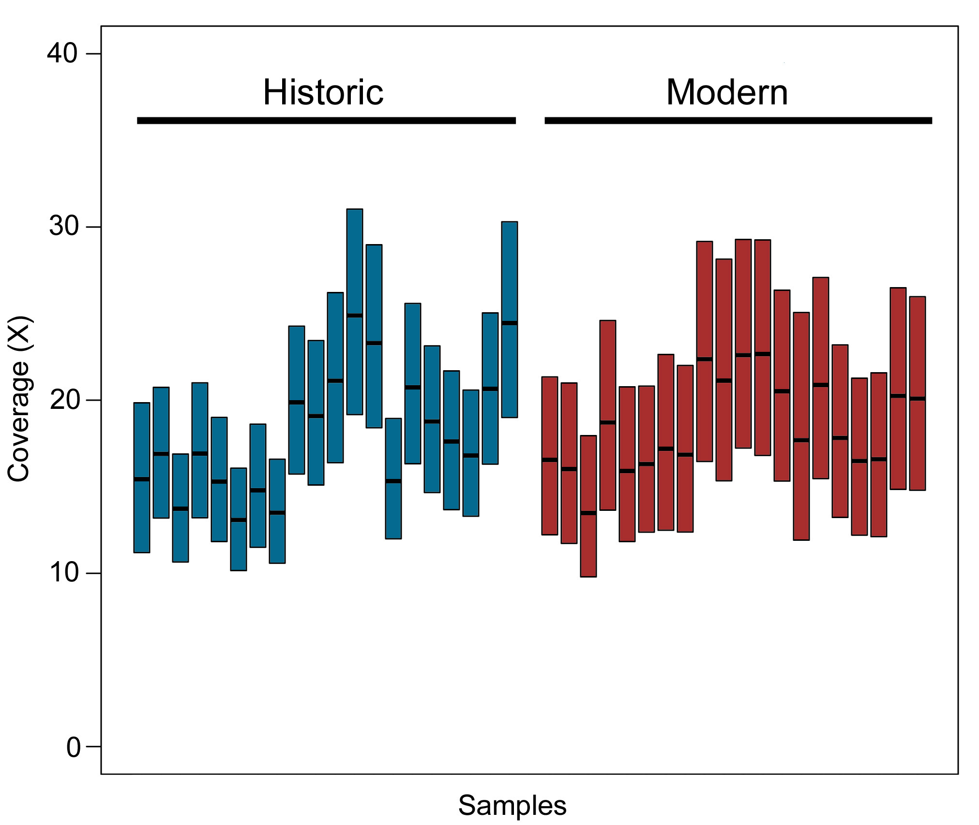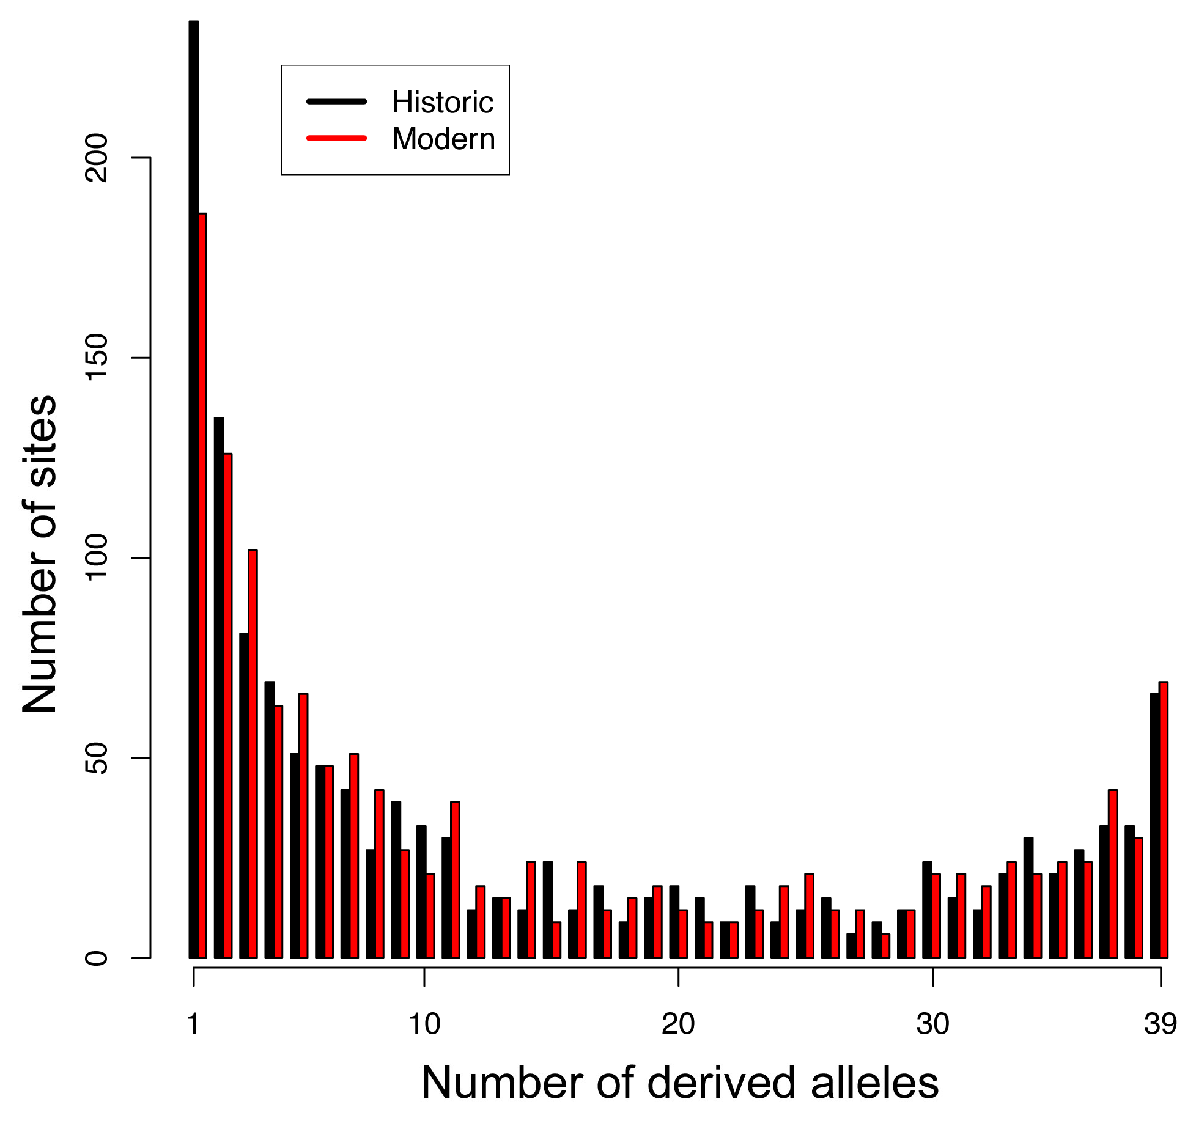

**Data integration & sharing**

Data generated from the Grinnell Resurvey Project has been gathered into a single publically-accessible webpage linked directly from the MVZ homepage (<http://mvz.berkeley.edu/Grinnell/>). This website includes a layperson description of the project and individual transects, links to annual reports, photo retakes, news coverage, personnel, and the specimen records, gathered into transect-based projects for both the resurveys (e.g., <http://arctos.database.museum/project/grinnell-resurvey-project-yosemite-transect>) and the historical surveys (<http://arctos.database.museum/project/historic-grinnell-survey-yosemite-transect>). These projects contain dynamically updated information on specimen numbers, other projects that have used the specimens, publications, and associated media and field

From October 2010 – September 2011, additional funding was received from the National Park Service to complete a planning project for resurvey work within the Great Basin and Mojave Desert regions. Using the methods developed as part of this grant, the goals of the new project were to compile the existing records (including specimen records, historic photos, field notes, and additional data) for the birds, mammals, and herps of the region, develop climate-based species distribution models for these species, identify potential resurvey sites based on these records and predictions, and develop a proposal to seek extramural funding for on- the-ground resurveys. This grant also provided funding to develop an online web portal to provide data compiled as part of the NPS grant to relevant parties (e.g., <http://arctos.database.museum/project/historic-grinnell-survey-death-valley-national-park>). This portal provides dynamic queries for all specimens, metadata, and project reports generated as part of the NPS grant. We have also incorporated data collected as part of this NSF grant in this web portal, providing a central and real-time updating database for any interested parties, including parks staff, researchers and the general public.